**Assignment 2: Code Script named DarrajHW3Q1.py :-**

import xlrd

from statistics import stdev

# Reads data from “AlexaReviews.xlsx”

def read_data():

records = {}

try:

wb = xlrd.open_workbook("AlexaReviews.xlsx")

sheet = wb.sheet_by_index(0)

for i in range(1, sheet.nrows):

color = sheet.cell_value(i, 2).lower().strip()

rating = sheet.cell_value(i, 1)

if rating:

records.setdefault(color, []).append(rating)

except Exception as err:

print("Exception while reading products data from file")

print(err)

return records

class DarrajHW3Q1:

# # Reads data from “AlexaReviews.xlsx”

products = read_data()

# Calculate the average star rating for all Alexa products

def compute_average_star_rating_all_products(self):

for color, ratings in self.products.items():

average = sum(ratings) / len(ratings)

average = round(average, 1)

print(f"Average Star Rating for Product {color.title()} = {average}")

# function for each of the two colors compute the average, minimum, maximum, range, standard deviation

def compute_each_two_colors(self):

while self.products:

color1, color1_ratings = self.products.popitem()

color2 = None

color2_ratings = []

if self.products:

color2, color2_ratings = self.products.popitem()

two_colors_ratings = color1_ratings + color2_ratings

colors_average = round(sum(two_colors_ratings) / len(two_colors_ratings), 1)

min_rating = min(two_colors_ratings)

max_rating = max(two_colors_ratings)

standard_deviation = round(stdev(color2_ratings), 2)

print(f"\nColors {color1} & {color2} average = {colors_average}")

print(f"Colors {color1} & {color2} minimum = {min_rating}")

print(f"Colors {color1} & {color2} maximum = {max_rating}")

print(f"Colors {color1} & {color2} range = ({min_rating} - {max_rating})")

print(f"Colors {color1} & {color2} Standard Deviation = {standard_deviation}")

if __name__ == "__main__":

# make class object

obj = DarrajHW3Q1()

# Call Function Calculate the average star rating for all Alexa products

obj.compute_average_star_rating_all_products()

# Call function for each of the two colors compute the average, minimum, maximum, range

# and standard deviation for the star rating

obj.compute_each_two_colors()

Program Output Screenshot:

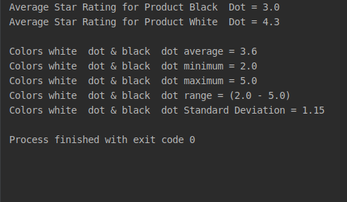

**Results Summary:-**

Being a successful brand also means you’re a visible one. Reviews have clear impact on sales. The computed results are Increasingly Essential to Decision Making. The results help amazon which products have low ratings and which products have good average rating and which one has maximum rating.